**PROJECT :ROBOTIC ARM DESIGN**



# Problem statement

Conceptualization and design of a pick and place 6 degree freedom robotic arm.

# Team members

1. Nichith C N – B.tech, Mechanical Engineering
2. Sooraj Krishna - B.tech, Mechanical Engineering
3. Surya kiran S - B.tech, Mechanical Engineering

SPECIFICATIONS OF

MOTOR ON EACH JOINTS

ASSUMPTIONS

▶

Assuming the following specifications for the robot arm and gripper:Mass of the payload = 10 kg Gripper has 3 jaws Arm has a base, 3 links, and 3 rotary joints Length of each arm link = 0.5 meters Angle between adjacent links = 120 degrees Gripper is oriented vertically and facing downwards Speed of movement = 3 m/s Based on these assumptions, the forces, torque, and power at each joint can be estimated as follows: ▶ Base joint: The force required to move the arm at a speed of 3 m/s with a payload of 10 kg is approximately 294 N. The torque required to rotate the base joint to maintain this movement is approximately 147 Nm. The power required to rotate the base joint at this torque and speed is approximately 441 W.

.

▶ Joint between the first and second link: The force required to move the arm at a speed of 3 m/s with a payload of 10 kg is approximately 245 N. The torque required to rotate this joint to maintain this movement is approximately 120 Nm. The power required to rotate this joint at this torque and speed is approximately 360 W.

▶ Joint between the second and third link: The force required to move the arm at a speed of 3 m/s with a payload of 10 kg is approximately 245 N. The torque required to rotate this joint to maintain this movement is approximately 120 Nm. The power required to rotate this joint at this torque and speed is approximately 360 W

▶ Gripper joint: The force required to hold the gripper closed around the payload is approximately 98 N.

GRIPPER

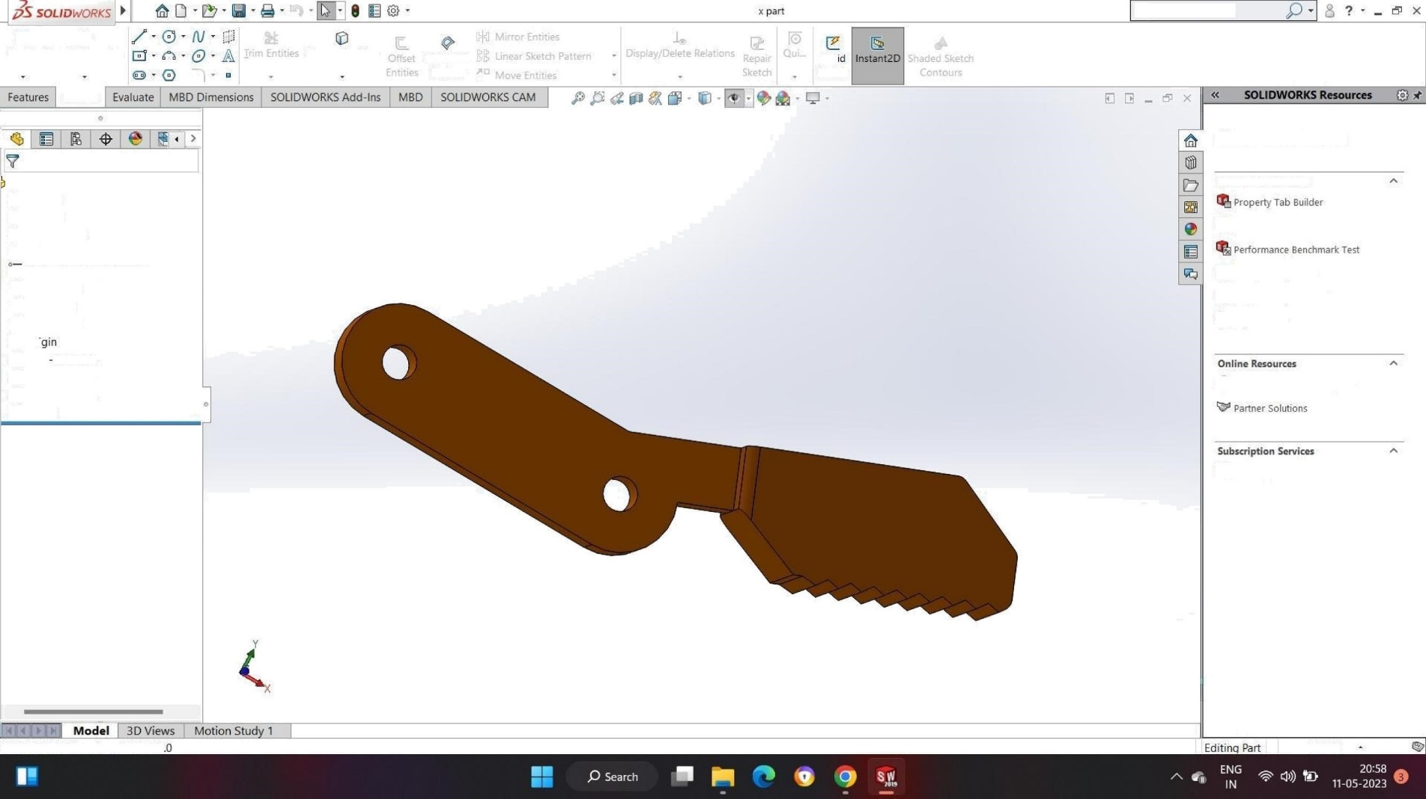

Sketch

Smart

Dimension

Sketch

x

part

(

Default

<

<

DefauIt

>

_DispIay

Sta

HistOry

Sensors

Annotations

Solid

Bodies(1)

gp

Material

<

not

specified

>

Front

Plane

Top

Plane

Right

Plane

Boss

Mrude

4

Boss

-

Mrude

5

Boss

-

Mrude

6

FiIIet

8

SOLIDWORKS

Premium

2019

SP5

Convert

Entities

Offset

On

Surface

Rap

Sketch

@

Search

Commands

Welcome

to

S

OLIDWORKS

SOLIDWORKS

Tools

SO

LIDWO

RKS

Rx

Compare

M

\

'

Score

Copy'

Settings

Wizard

My

Products

3

DEXpERIENC

E

Marketplace

S

ub

s

cription

Services

MMGS

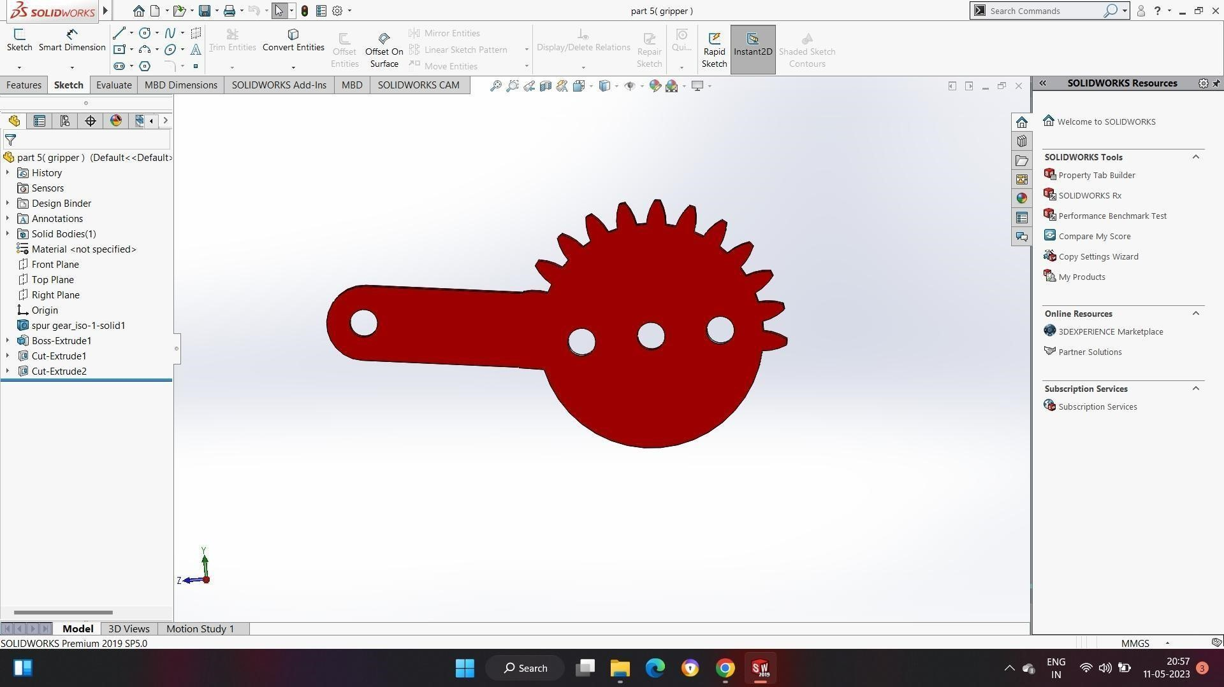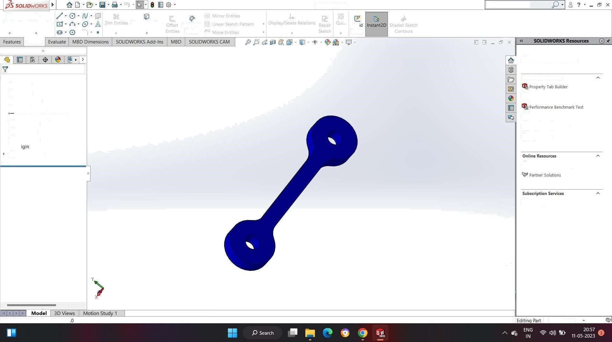

Sketch

Smart

Dimension

Sketch

@

part

2

(

grip

per

)

(

Default

<

<

DefauIt

°

HistOry

'

°

Sensors

Annotation

Solid

Bodies(1)

gp

Material

<

not

specified

>

Front

Plane

Top

Plane

Right

Plane

L.

o

Bass

-

Mrude1

FiIIet1

SOLIDWORKS

Premium

2019

SP5

Convert

Entities

Offset

On

Surface

part

2

(

gripper

)

Rap

Sketch

@

Search

Commands

Welcome

to

S

OLIDWORKS

SOLIDWORKS

Tools

SO

LIDWO

RKS

Rx

Compare

M

\

'

Score

Copy'

Settings

Wizard

My

Products

3

DEXpERIENC

E

Marketplace

S

ub

s

cription

Services

MMGS

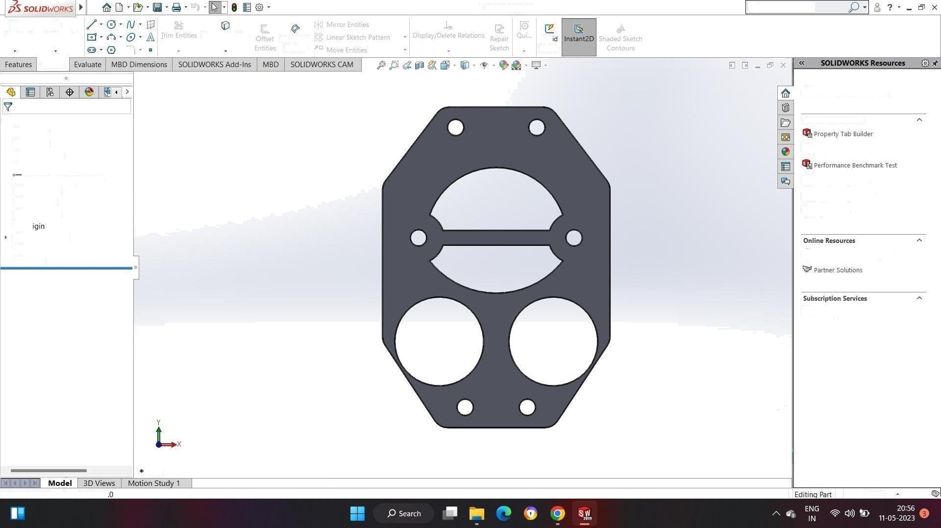

Sketch

Smart

Dimension

Sketch

°

'

°

Part3

(

grip

per

)

Default

(

<

<

DefauIt

>

HistOry

Sensors

Annotation

Solid

Bodies(1)

gp

Material

<

not

specified

>

Front

Plane

Top

Plane

Right

Plane

L.

o

Bass

-

Extrude1

FiIIet1

FiIIet2

SOLIDWORKS

Premium

2019

SP5

Front

Convert

Entities

Offset

On

Surface

Part3

(

tripper

)

Rap

Sketch

@

Search

Commands

Welcome

to

S

OLIDWORKS

SOLIDWORKS

Tools

SO

LIDWO

RKS

Rx

Compare

M

\

'

Score

Copy'

Settings

Wizard

My

Products

3

DEXpERIENC

E

Marketplace

S

ub

s

cription

Services

MMGS

